**Policy Memo 3: Policy Into Action**

The inefficiency in implementing educational scholarships in Mexico has significantly challenged the country's educational advancement and development, particularly regarding the increasing school dropout rates. This policy memo will address the transition from secondary to high school, which has the highest dropout rates. 43% of 23-45-year-olds have not received upper secondary education (Campos-Vazquez, 2018). The National Scholarships Program, recently developed by the Ministry of Education, aims to alleviate students' financial struggles with minimal stipulation (Secretariat of Public Education, n.d.). However, this program has not succeeded in decreasing dropout rates. The primary reason behind this gap is the ineffective funding structures that fail to target students from the most financially disadvantaged backgrounds, do not assess the scholarship recipients' eligibility, or track their progress after receiving the scholarship.(Hoyos, 2021). If the inefficiency of such scholarships is not addressed, it could lead to increased polarization and potentially higher dropout rates for future generations.

As seen in Appendix A, the program aims to target the demographic intersection at the highest risk of dropping out: students from the lowest socio-economic backgrounds transitioning to high school. Based on research on the current Mexico scholarship program, the key assumptions behind this theory of change are that insufficient scholarship amounts, poor audience selection, and a lack of accountability drive the poor high-school retention rates of scholarship students. The program will begin by identifying scholarship beneficiaries, considering that previous programs have not reached the target population (Soto 2022), and the money that families receive is inadequate to support even an individual (929 MXN pesos/54 USD). (Puebla 2023). The policy must ensure that the most financially needy students receive an adequate scholarship amount and utilize it.

We propose a pilot scholarship program in Mexico's most socio-economically disadvantaged technical secondary schools, covering the following points: 1) Additional financial aid, in collaboration with the Ministry of Education, national companies, i.e., BIMBO, and, in the long term, international organizations like the Global Partnership for Education Fund, to increase the financial grant to align with the country's cost of living. 2) Implementation of criteria to apply for the scholarship, which considers financial background, previous attendance, and general results without discouraging the idea of applying. 3) An attendance and performance tracking system for scholarship students to ensure effective utilization of the scholarship. Given that the goal is to increase high school retention rates, performance tracking will be limited to having passing grades in required classes. The underlying assumption is that motivated students can make better use of scholarship money and that increased accountability is focused on engagement (and not performance) can motivate students to attend school.

As seen in Appendix B, the primary input is additional funding which will contribute to increasing scholarship packages, appointing staff, and building technical and administrative capacity for monitoring and tracking. The first activity will be developing a system for efficiently choosing scholarship recipients from a chosen low-income area that considers metrics such as financial background, previous attendance and passing grades. Based on this eligibility, a pilot class will be created with first-year students in the poorest quartiles of a chosen secondary school in the same area. This approach follows what has been proven effective in countries such as Indonesia through the Social Safety Net scholarship program (Cameron 2009). The second activity will focus on assessing utilizing the scholarships. Community engagement is necessary in the form of teacher and parental support to ensure recipients make use of their scholarships. This involves community members, such as teachers, parents, students, and village representatives, forming a school committee to select beneficiaries and track attendance and dropout rates. This approach has been effective in other countries (Cameron 2009). Due to increased accountability and tracking of eligible students, the short-term outcomes of the program are increased student attendance and consistency, enhancement in the level of student participation in learning processes, and better academic outcomes in terms of general scores or extracurricular engagement. The long-term outcomes are a reduction in the number of students leaving school during critical transitional phases and narrowing the gap between different socio-economic groups within the educational system. Moreover, having a rigorous and reliable system for disseminating scholarships will encourage international educational organizations to support Mexico's scholarship program if the pilot program demonstrates concrete improved educational outcomes. The target outcomes are 40% attendance in the first three years and an additional 5% in the 4th year.

The policy requires robust monitoring and evaluation procedures to demonstrate improved educational outcomes. This monitoring and evaluation would be conducted by an external non-governmental organisation (preferably international for minimal bias) for eg. Global Impact Investing Network. The graduation rates of the pilot program with first-year students who received the scholarship will be compared to the classes above them who did not receive this scholarship. This approach has been effective through previous programs in Mexico, such as PROGRESA in the 1990s (BID 2001). Additional metrics like average attendance and the number of people with passing grade point average (7/10) for the pilot class will be collected annually until graduation by the school committee consisting of parents, teachers and community members. The database of students eligible for the scholarship based on financial background and past track record will be reviewed by the MoE annually. Additionally, the pilot class and the school committee of parents and teachers (in charge of tracking attendance and performance) will be asked for feedback after their graduation from high school both quantitatively through surveys for all the students and smaller focus group interviews to understand their thoughts on the program and what can be improved.

**Bibliography**

BID. 2001. “BID | Programa Social Progresa Quiebra Circuito de Pobreza Extrema En México.” Www.iadb.org. June 5, 2001. <https://www.iadb.org/es/noticias/programa-social-progresa-quiebra-circuito-de-pobreza-extrema-en-mexico>.

Cameron, Lisa. 2009. “Can a Public Scholarship Program Successfully Reduce School Drop-Outs in a Time of Economic Crisis? Evidence from Indonesia.” *Economics of Education Review* 28 (3): 308–17. <https://doi.org/10.1016/j.econedurev.2007.09.013>.

Gobierno de México; Gobierno De México.

<https://www.gob.mx/sep/articulos/boletin-257-combate-sep-desercion-escolar-con-becas-para-el-bienestar->

Puebla, A. (2023, August 29). *What is the cost of life of the Mexicans?* El Universal; El Universal. https://www.eluniversal.com.mx/opinion/armando-puebla/cual-es-el-costo-de-vida-de-los-mexicanos/

Soto, Dulce. 2022. “Becas Del Bienestar Llegan Solo a 42% de Estudiantes En Pobreza, Reporta Coneval.” ADNPolítico. December 17, 2022. https://politica.expansion.mx/mexico/2022/12/16/becas-del-bienestar-llegan-solo-a-42-de-estudiantes-en-pobreza-reporta-coneval.

**Appendix A**

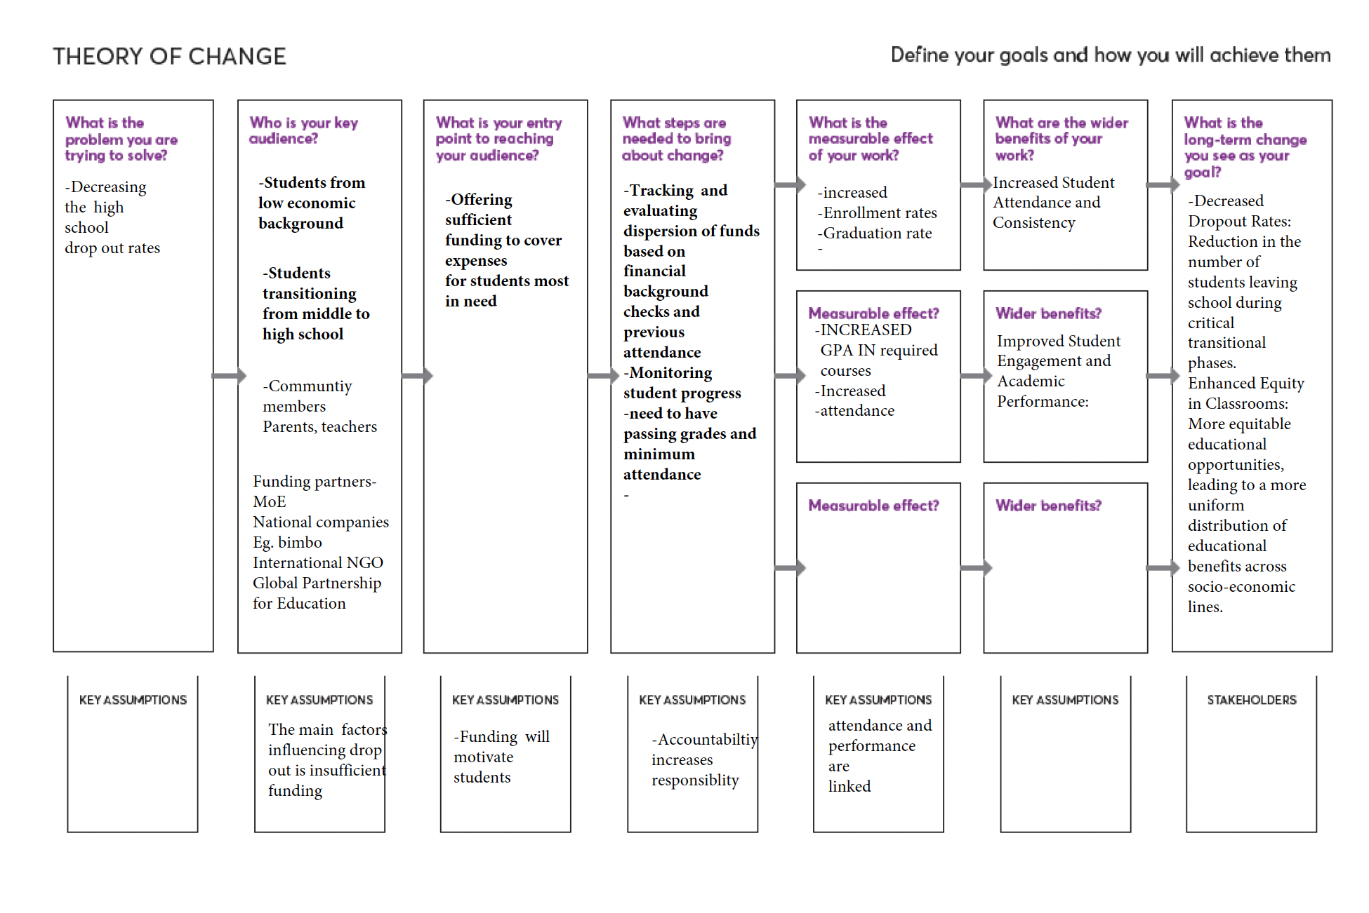

**Appendix B**

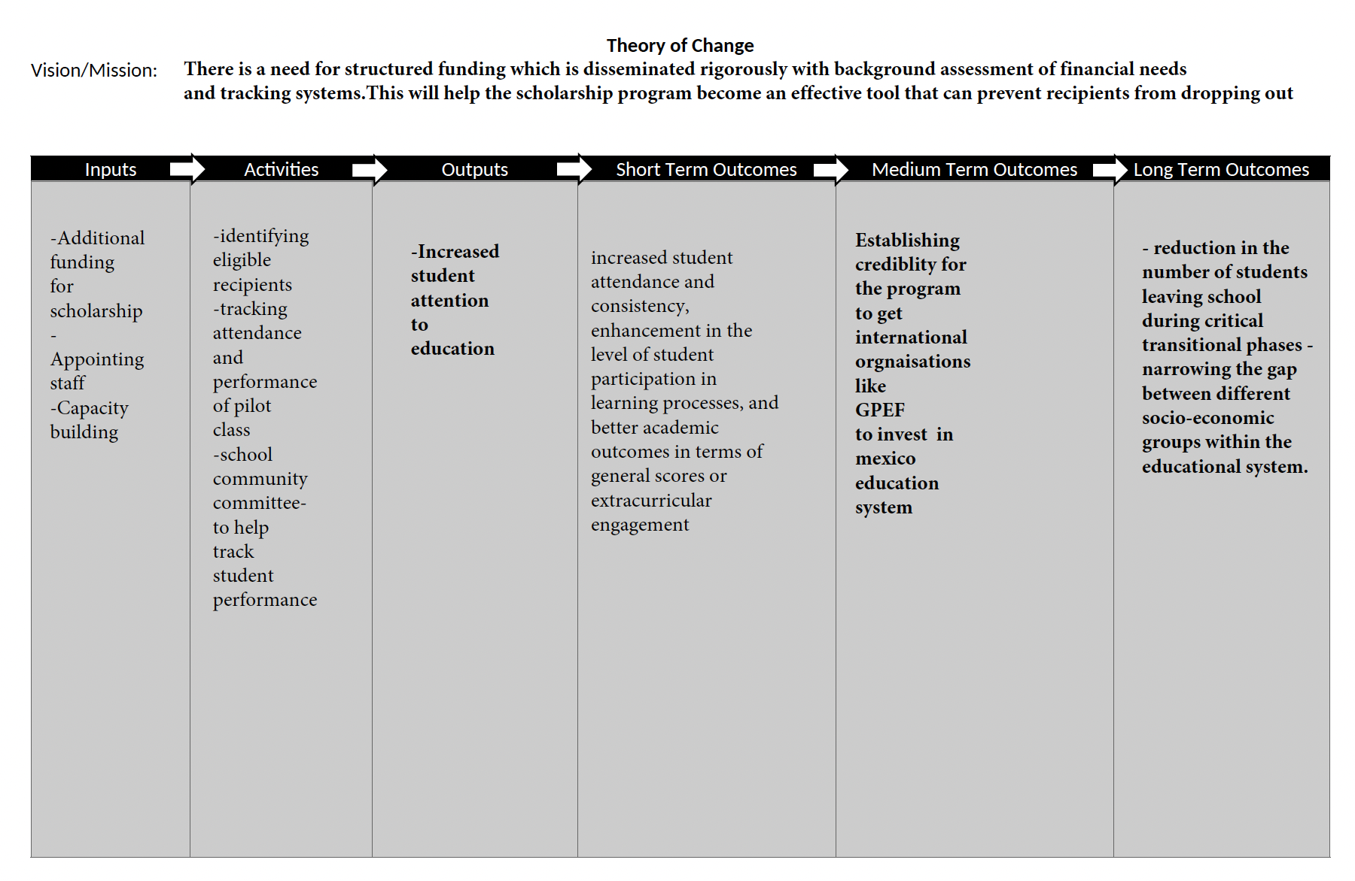

**Appendix C**

Table: Monitoring and Evaluation Metrics

|  |  |  |
| --- | --- | --- |
| **Expected outcomes** | **Indicators** | **M&E Strategy** |
| Decreased drop-out rates | Enrollment rates from year to year of the students participating in the program. | Start a **pilot program** in the regions identified as the poorest through household data. The program will initially only allow first-year students in the poorest quartiles at these schools to be enrolled. This way, the funds can be allocated to the students who are most at risk of actually dropping out, and it will also facilitate the monitoring of the program's impact. |
| Comparison of enrollment rates with the low-income students that are not receiving the scholarship from the year above of the first class enrolled in the program. |  |
| Improved commitment of the students | Attendance reports | **Improve the scholarship recipients' commitment to their studies and to stay at school** by getting community members, such as teachers, parents, students, and village representatives, to form a school committee to choose the beneficiaries and track attendance and drop-out rates. |
| Improved eligibility criteria | Household income data | Schools in charge of collecting this data through surveys |
| Attendance reports | Improve the scholarship recipients' commitment to their studies and to stay at school by getting community members, such as teachers, parents, students, and village representatives, to form a school committee to choose the beneficiaries and track attendance and drop-out rates. |